SUBOL

Career Education and Development Portal

User (Visitor) Manual

Version 1.0

December 2019

Contents
1. Introduction 3
2. Getting Started 3
2.1 Homepage 3
2.2 SUBOL Services 7
2.2.1 Career Orientation Scale 7
2.2.2 Career Path 8
2.2.2.1 Arabic Classification 9
2.2.2.2 Singaporean Classification 12
2.2.3 Majors 13
2.2.4 Future Careers 18
2.2.5 Career Development Tools 20
2.3 Registration Process 32
2.4 Online CV Builder/ Maker 37
2.5 Registered User Profile 43

Introduction
The Career Education and Development Portal (SUBOL), an initiative of the Human Resources Development Fund (HADAF), aims to enable Saudi students, job seekers and employees to make career choices appropriate to their abilities and tendencies through an integrated system of career education and development services. This document provides a detailed explanation of SUBOL services.

Getting Started
To get started, go to the link: https://subol.sa through your browser (we recommend using Google Chrome for a better user experience). After signing in via the link, the homepage will appear, from which you can view the content.

Homepage
The homepage shows all SUBOL services for registered users and visitors. However, there are some services that require logging in. Figure 1 shows the main user interface of SUBOL Portal. At the top of the page, you can access basic hyperlinks, color settings, a search field, all SUBOL services (will be detailed in 2.2), and SUBOL introductory video. The homepage also contains the four user journeys:
1) High School Student
2) University/ Diploma Student
3) Job Seeker
4) Employee
These journeys take the user on a tour of all SUBOL portal services, as shown in Figure 2.
In addition, the homepage shows:
- Latest News (Figure 3)
- Online CV Builder/ Maker (Figure 4)
The bottom of the homepage contains:
- HADAF Social Media Links
- Unified Contact Number
- Terms and Conditions
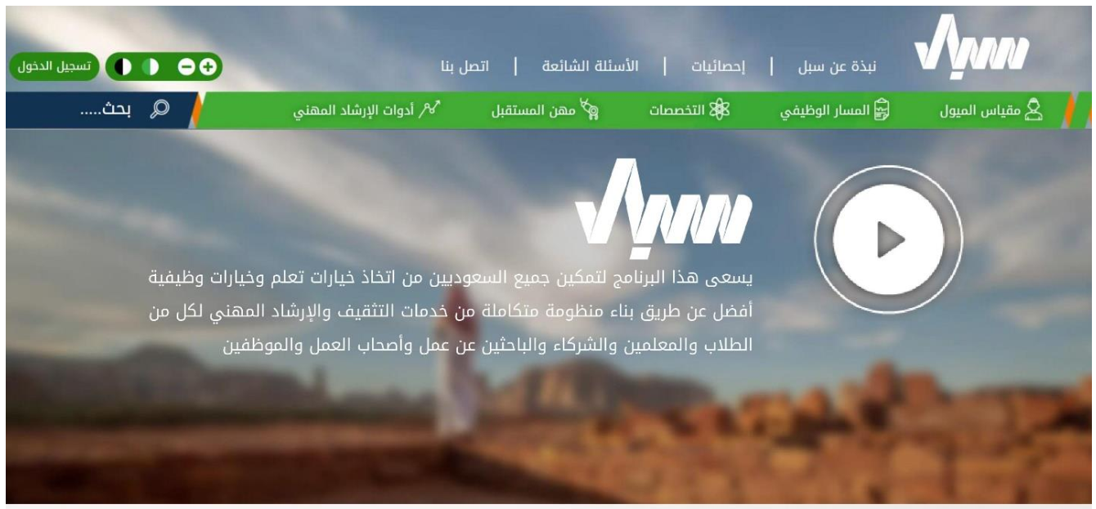
Fig. 1: Top of SUBOL Homepage
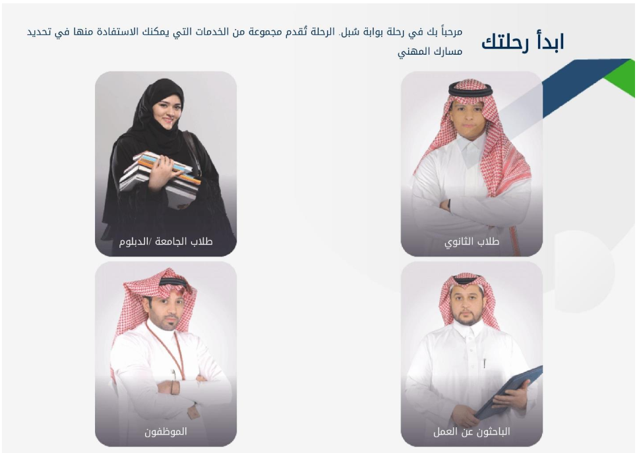
Fig. 2: SUBOL Homepage - Registered User Journeys.

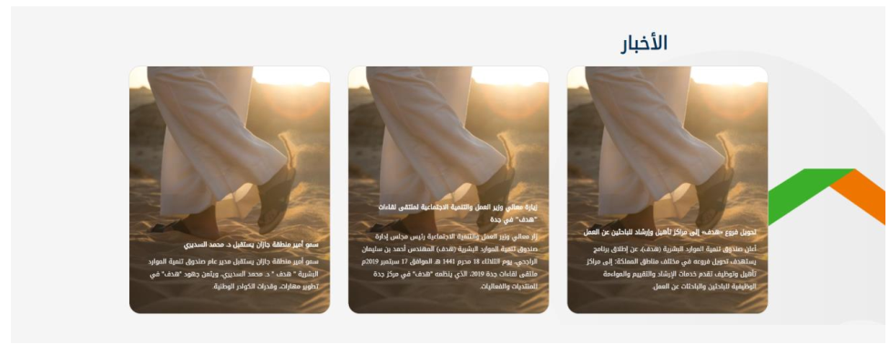
Fig. 3: SUBOL Homepage - Latest News.
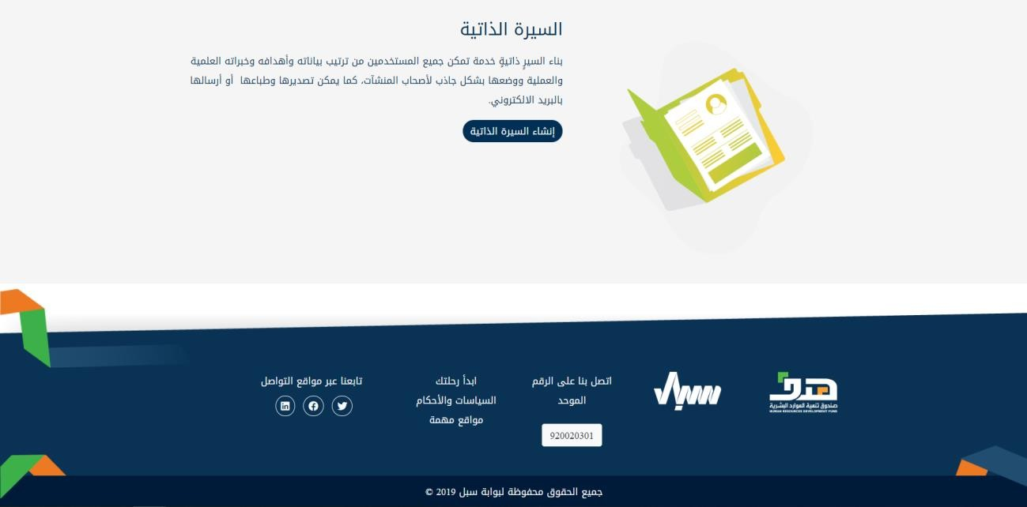
Fig. 4: SUBOL Homepage - Online Resume Builder Tool.

SUBOL Services
SUBOL Portal provides the following services for both visitors and registered users:

Career Orientation Scale
The registered user can take a test to determine his/her career orientation through going to the career orientation page link found at the top of the homepage, then clicking “Go to Test Page” (Fig. 5). However, visitors are required to log in to get this service.

Note: Every time the registered user takes the career orientation test, the test results will be saved in his/her personal profile at SUBOL Portal and he/she can review them at any time.

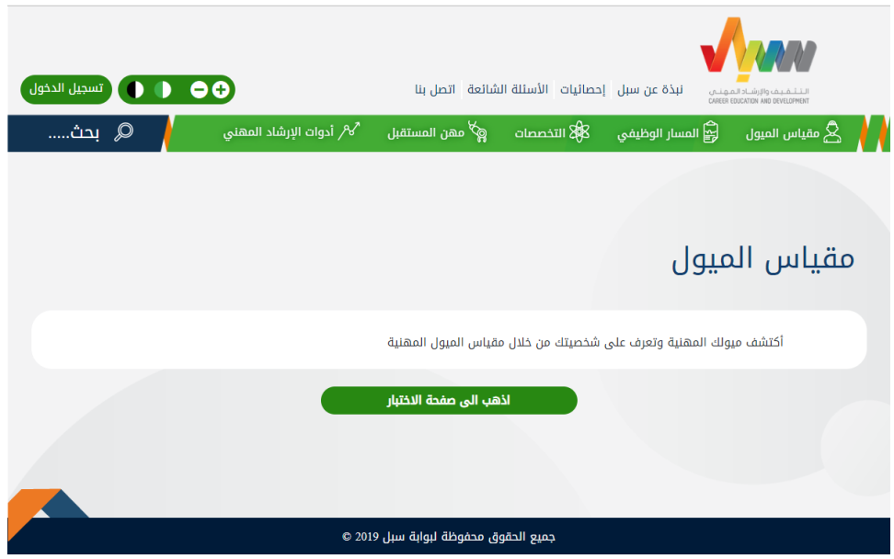
Fig. 5: Page of Career Orientation Scale.

Career Path
Registered users and visitors can view career paths according to the Arabic and Singaporean classifications through the Career Path page found at the top of the page.

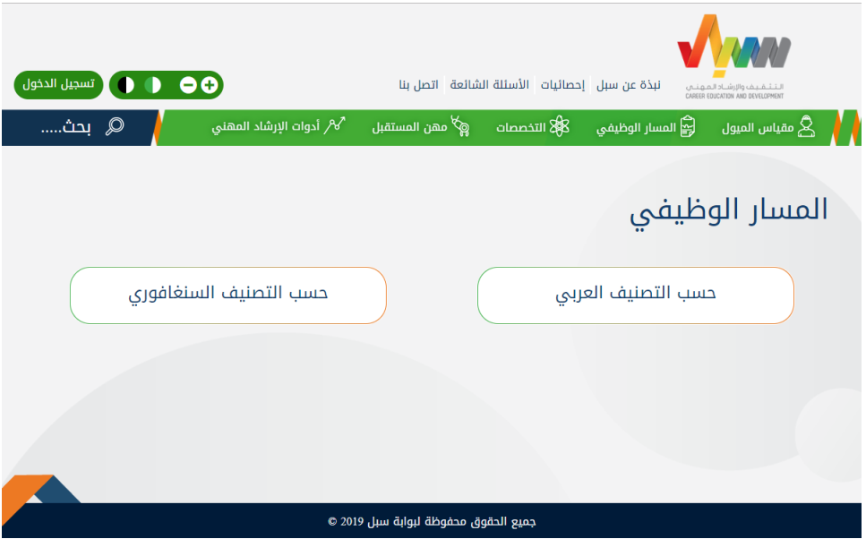
Fig. 6: Page of Career Path.

Arabic Classification
Registered users and visitors can view Arabic classification careers by:
- Academic Level
- Years of Experience
- Academic Discipline / Field

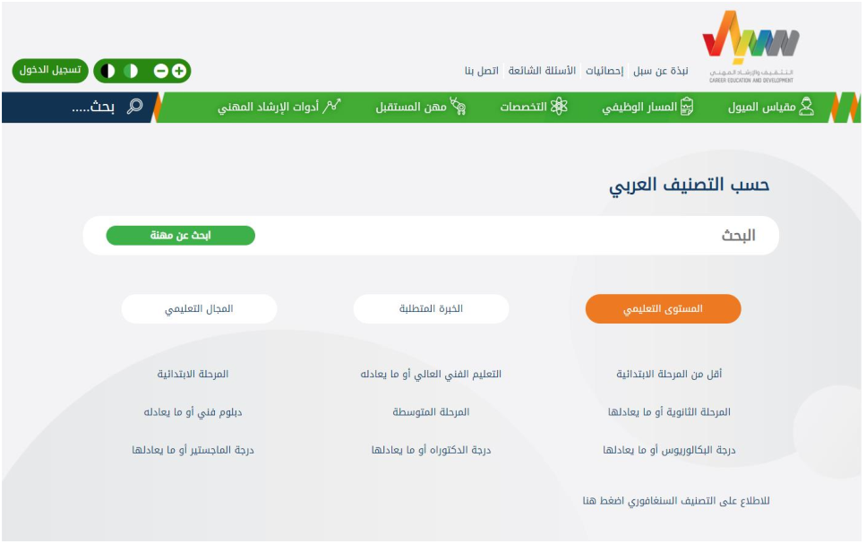

Visitors and registered users can also search in Arabic classification careers by:
- Academic Level
- Years of Experience
- Academic Discipline / Field
- Academic Major
(See Fig. 7)

It is also possible to review the details of each career and compare them. The registered user can star or bookmark his/her favorite careers so he/she can easily go back to them in the Starred tab or folder.
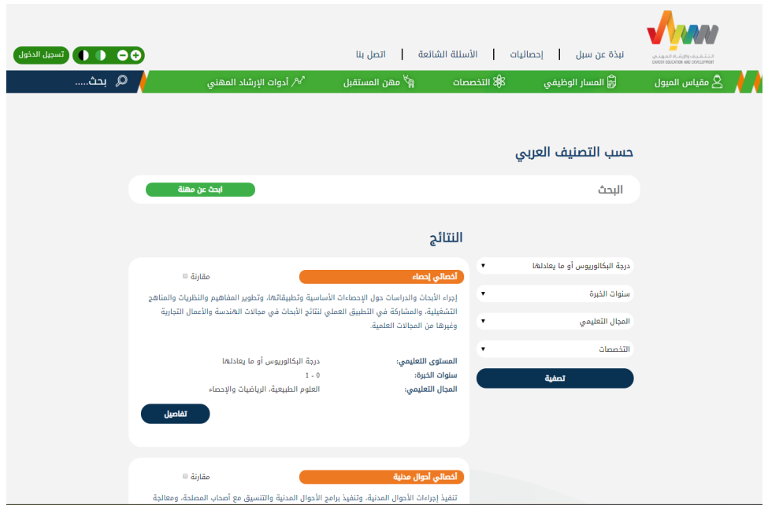
Fig. 7: Career Search Results.

The registered user can also compare careers (at least three careers) by pressing “Compare” next to the career name (Fig. 7) and then pressing the “Comparison Results” button at the bottom of the page to display the comparison results (Fig. 8).

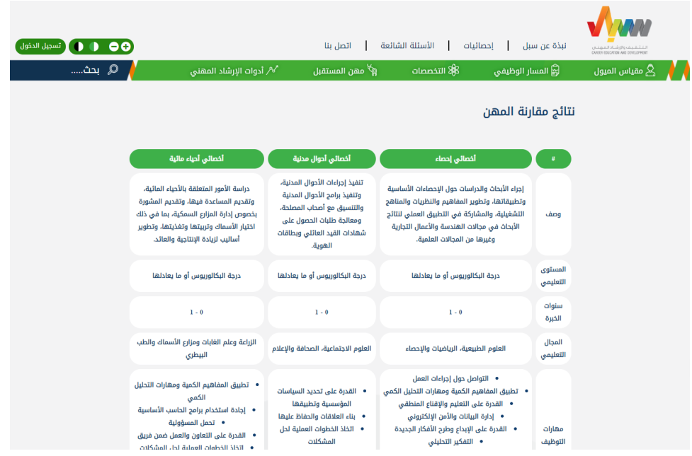
Fig. 8: Career Comparison Results.

Singaporean Classification
Visitors and registered users can also search in Singaporean classification careers by:
- Career Field / Discipline
- Major
It is also possible to review the details of each career.

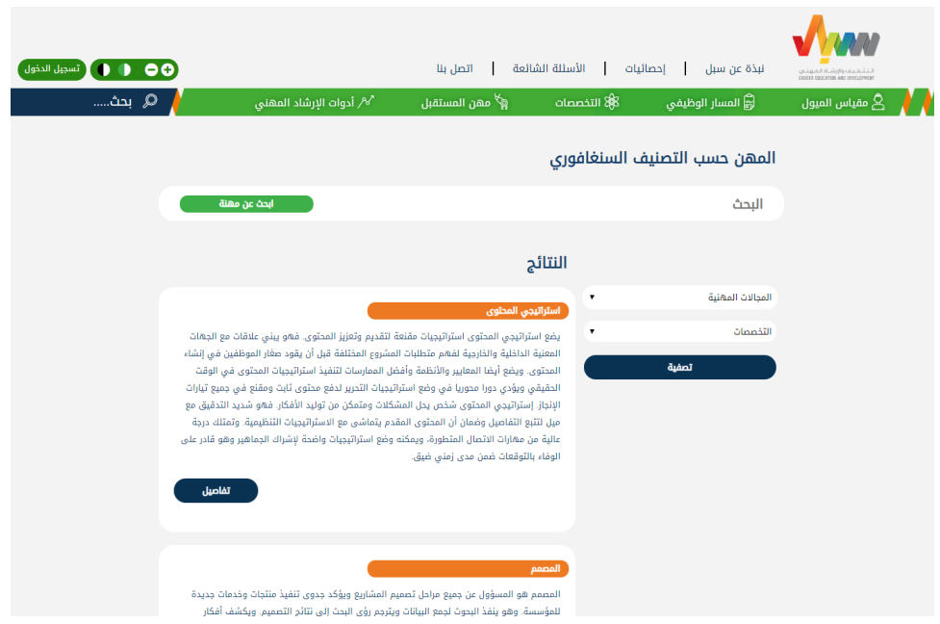
Fig. 9: Search Results in the Singaporean Classification.

Majors
Registered users and visitors can review career fields and majors in Saudi universities (Fig. 10) by clicking “Majors” in SUBOL Services. Fig. 11 presents the scientific fields and majors in each field for BA and diploma students in each major, as in Fig.12.
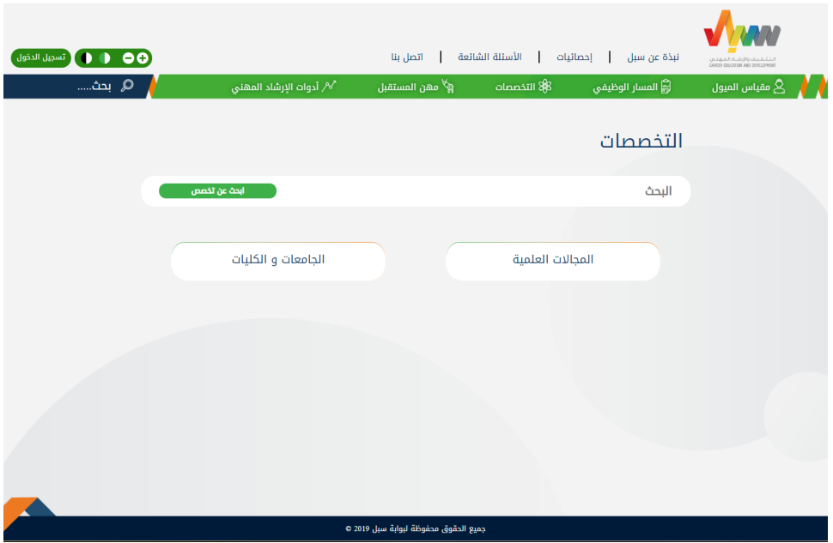
Fig. 10: Majors.

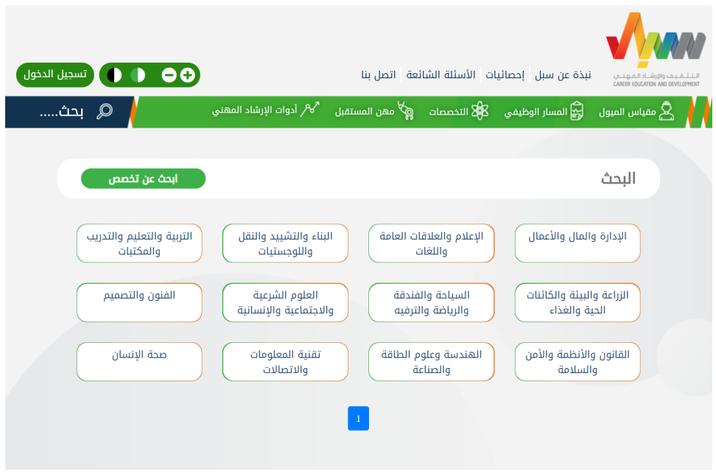
Fig. 11: Scientific Fields.

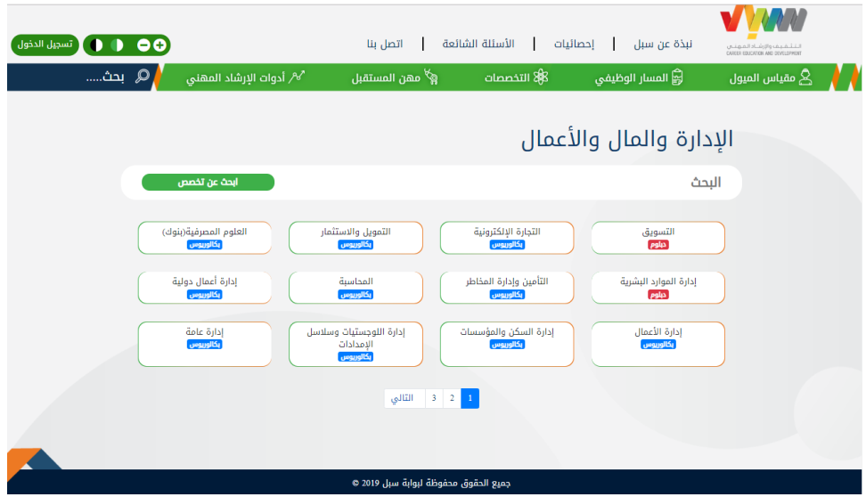
Fig. 11: Scientific Fields - Majors.

Furthermore, the user can view the list of (public and private) Saudi universities by pressing “Universities and Colleges” (Fig. 10), which will display a list of universities (Fig. 13). You can view the list of majors in any university by clicking on the university name (Fig. 14).

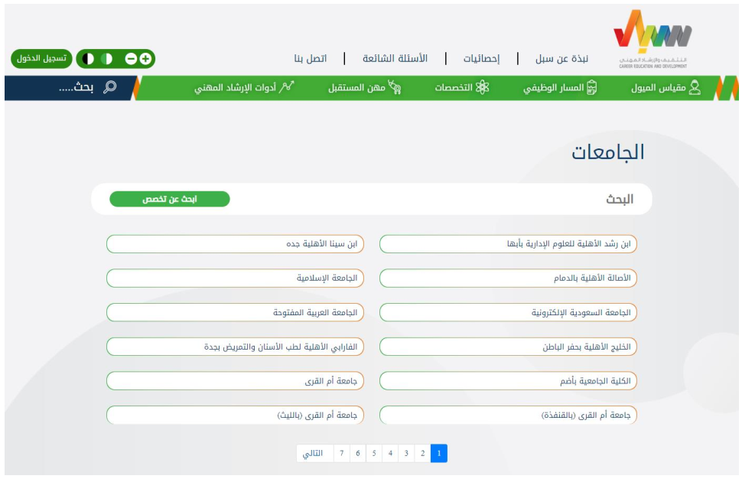
Fig. 13: Saudi Universities and Colleges

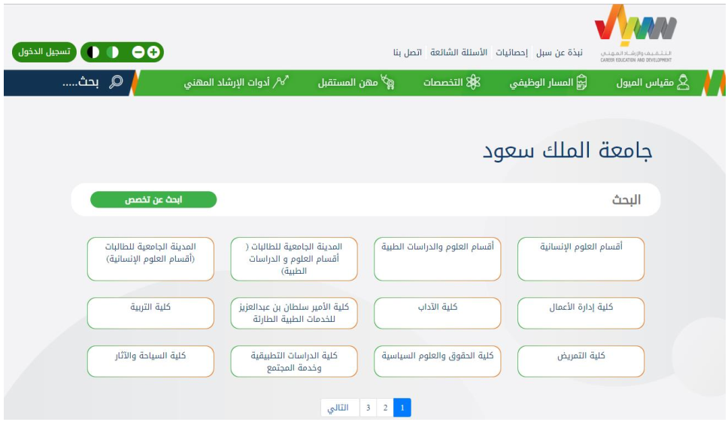
Fig. 14: Universities - List of Majors

Future Careers
Registered users and visitors can view the list of future careers by selecting Future Careers from SUBOL Services (Fig. 15). It is also possible to search and view the details of each career and star or bookmark favorite careers.

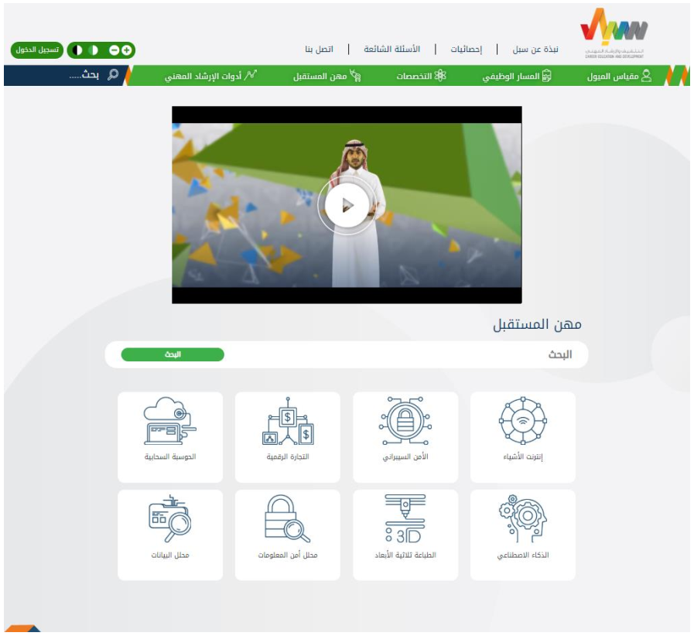
Fig. 15: Future Careers

Career Development Tools
Registered user and visitor can take advantage of career development services by selecting Career Development Tools from SUBOL Services. The services provided to the visitors are as follows:

- Inspirational Stories: Videos showing success stories in different fields.
- CV Preparation Skills: A guide article for CV preparation.
- Articles to Enhance Your General Knowledge.
- Interview skills: A guide article for personal interviews.
- Joining the Career Development Network of SUBOL.
- A list of relevant career education and development standards.
- Career Week: An interactive fund to educate high school students about different career paths, necessary skills, entrepreneurship skills, guidance and development.
- Career Mentor Development Certificates Link.

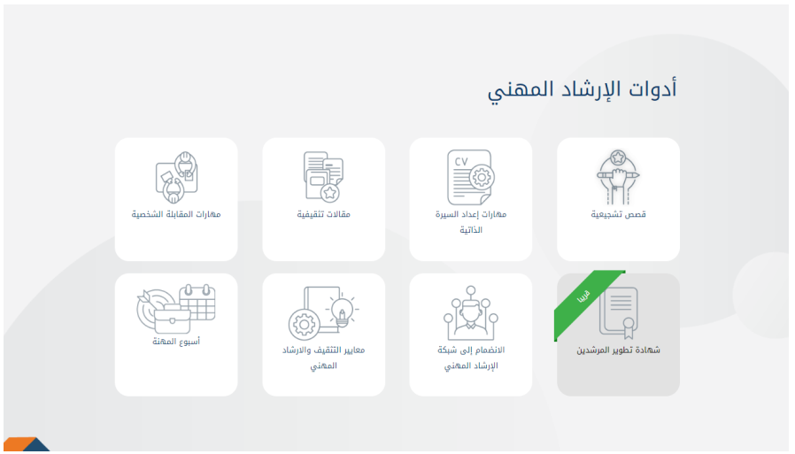
Fig. 16: Career Development Tools - Visitors

Furthermore, there are additional services that are provided only to job seekers of registered users, such as communicating with a career mentor, including:

- Booking a career development session with a career mentor at one of HADAF's branches.
- Booking a career development session over the phone with a career mentor.
- Booking a career development ticket.

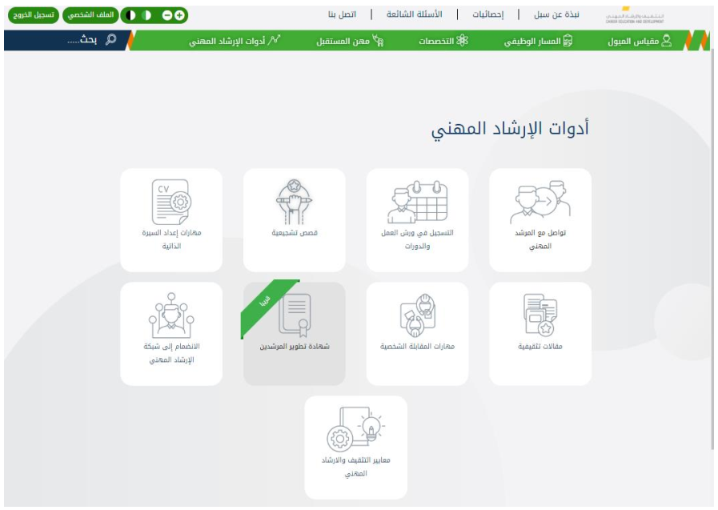
Fig. 17: Career Development for the Registered User.

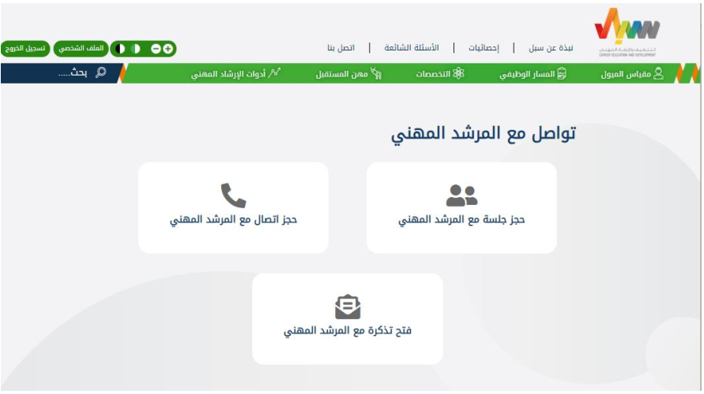
Fig. 18: Communication with Career Mentors.

- Booking A Career Development Session with A Career Mentor:
When selecting "Booking A Career Development Session with A Career Mentor", you will be taken to the booking page in order to specify the purpose, place and date. The date must be two working days after the date of the booking (Fig. 19). Then, choose the appropriate session time from the list (Fig. 20) and confirm the reservation information (Fig. 21) to be reviewed and approved (Fig. 21).

- Booking A Call with A Career Mentor:
When selecting "Booking A Call with A Career Mentor", you will be taken to the booking page in order to specify the purpose and date. The date must be two working days after the date of the booking (Fig. 23). Then, choose the appropriate session time from the list (Fig. 24) and confirm the reservation information to be reviewed and approved (Fig. 25).

- Booking A Ticket with A Career Mentor:
When selecting "Booking A Ticket with A Career Mentor", you will be taken to the ticket page (Fig. 26). Upon filling in all the required fields and submitting the ticket, you will receive a response from the career mentor (the response will be available in the user's profile).

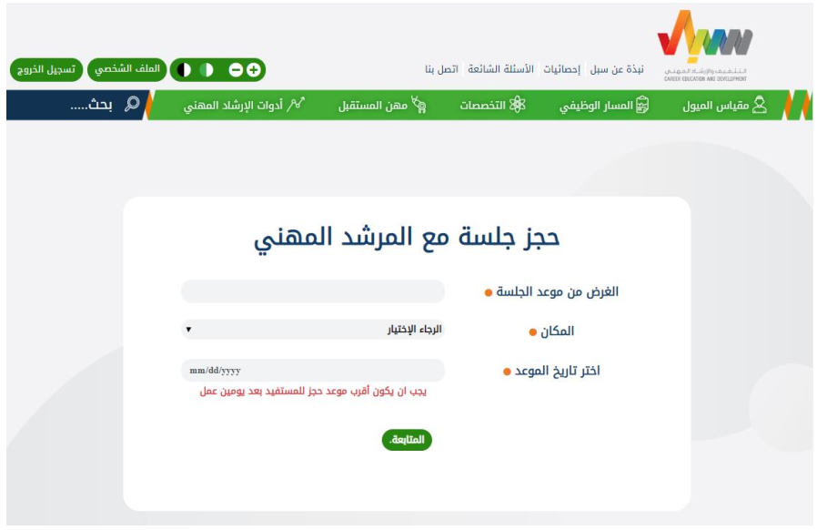
Fig. 19: Booking A Career Development Session with A Career Mentor - Part 1.

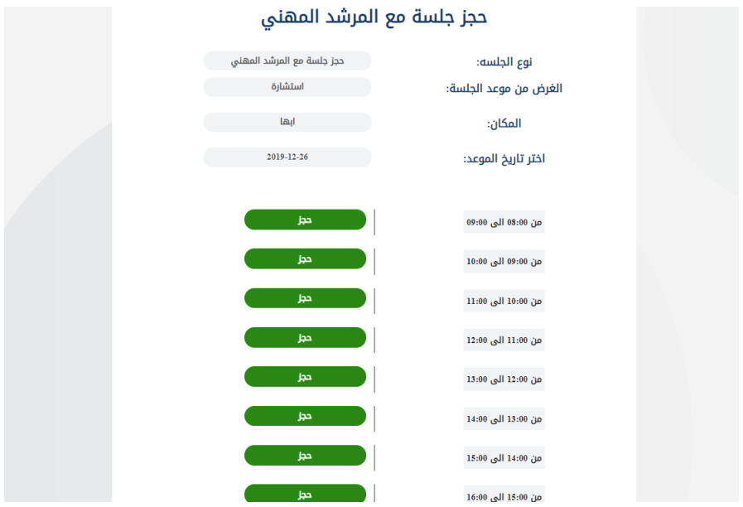
Fig. 20: Booking A Career Development Session with A Career Mentor - Part 2.

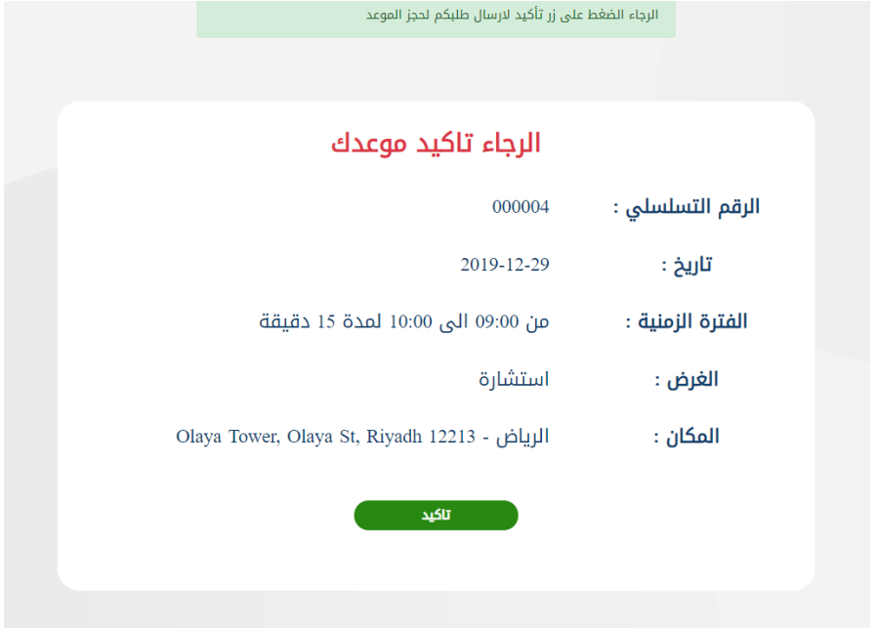
Fig. 21: Booking A Career Development Session with A Career Mentor - Part 3.

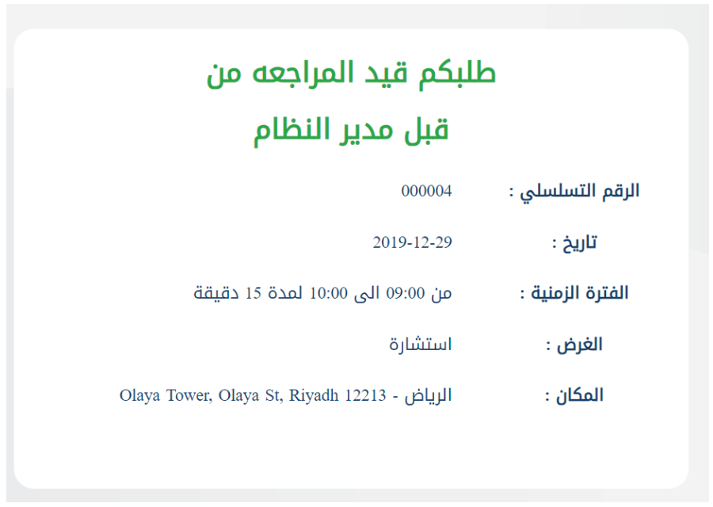

Fig. 22: Booking A Career Development Session with A Career Mentor - Part 4.

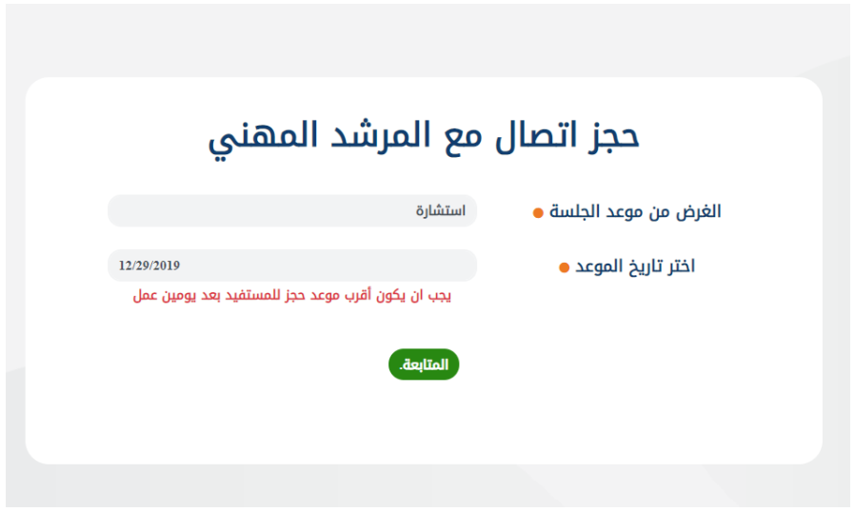
Fig. 23: Booking A Call with A Career Mentor - Part 1.

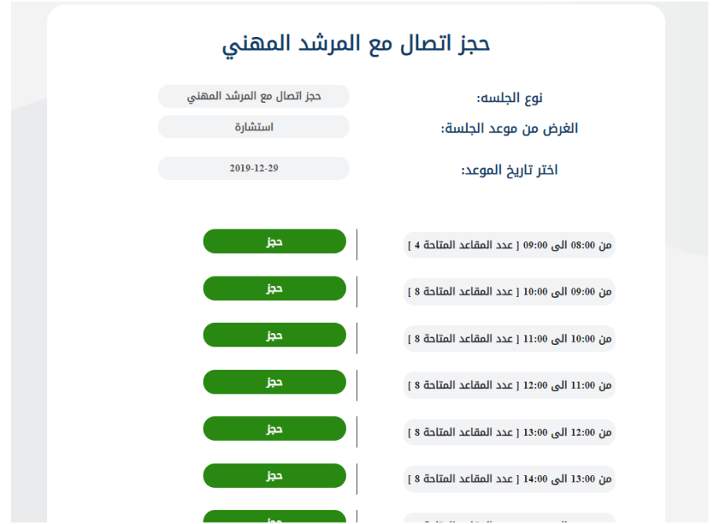
Fig. 24: Booking A Call with A Career Mentor - Part 2.

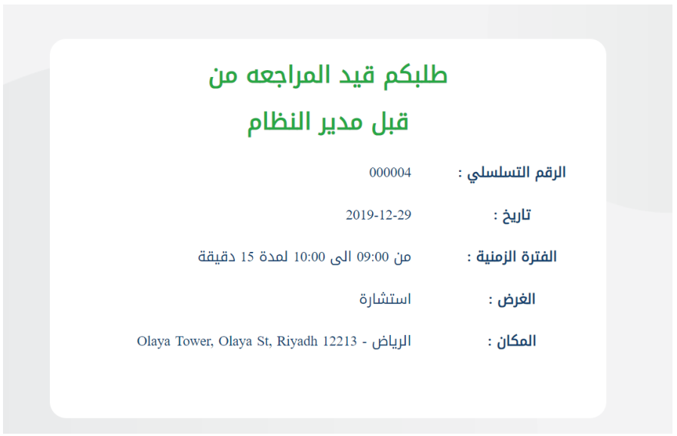
Fig. 25: Booking A Call with A Career Mentor - Part 3.

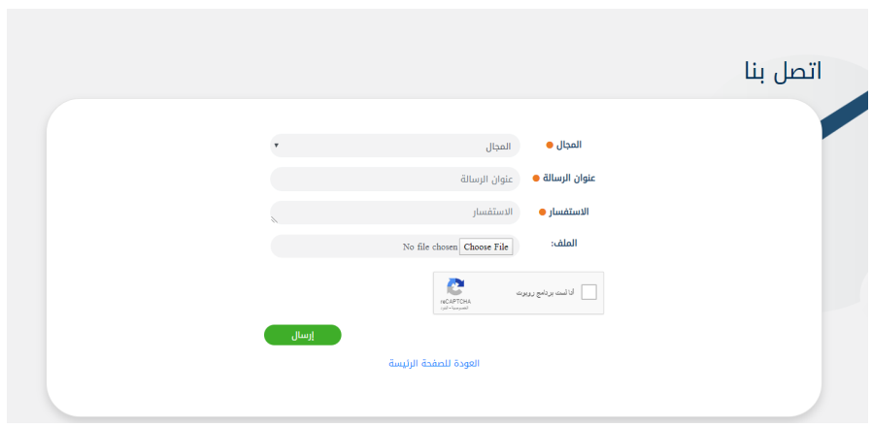
Fig. 26: Booking A Ticket with A Career Mentor

Registration Process
To register in SUBOL, click “Login” from the top bar, and then “Register” as shown in Fig. 27; then enter the ID number and date of birth as in Fig. 28, and complete the rest of registration details as required (Fig. 29).

Note: A valid mobile number and email address must be used. Use the same email address used in DOROOB to link your DOROOB courses with SUBOL.

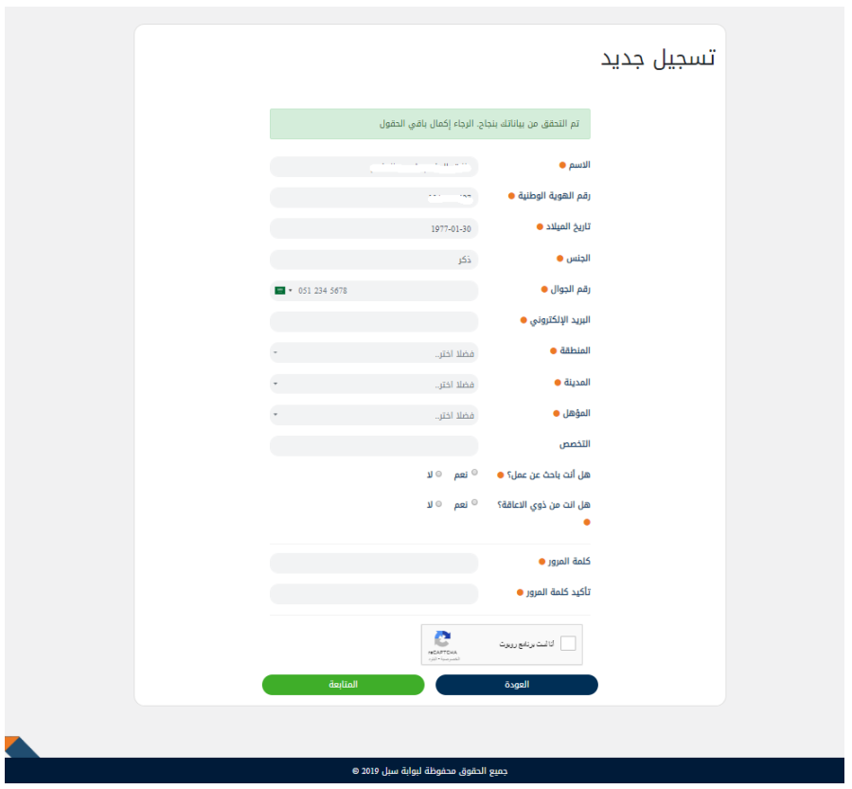

Confirm the mobile number by entering the verification code, and activate the e-mail by opening the link sent to the registered e-mail.

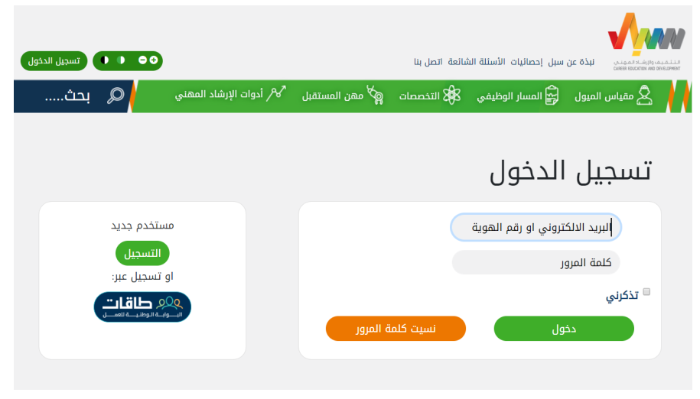
Fig. 27: New Registration.

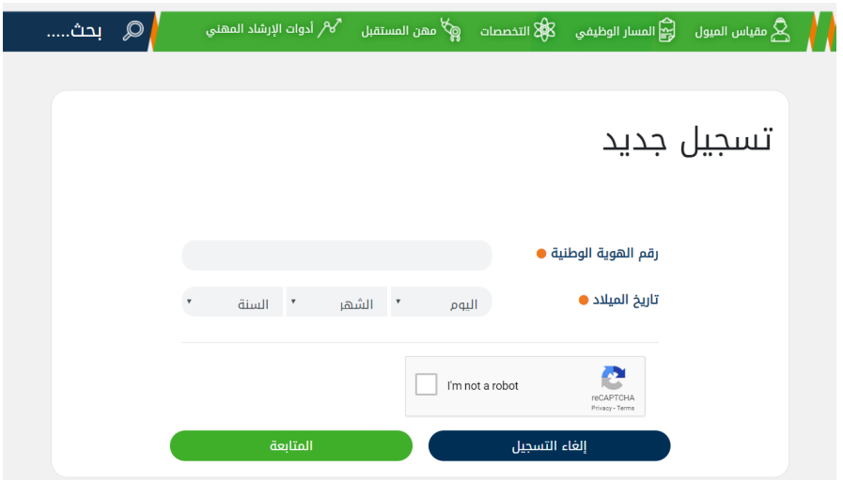
Fig. 28: First Stage - Registration in SUBOL.

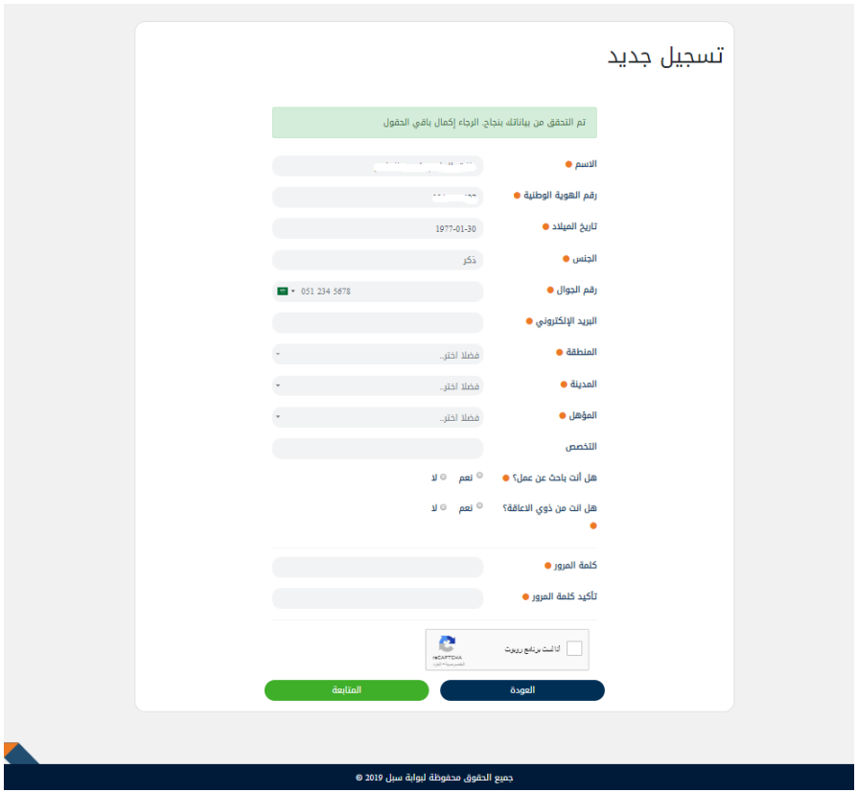
Fig. 29: Second Stage - Registration in SUBOL.

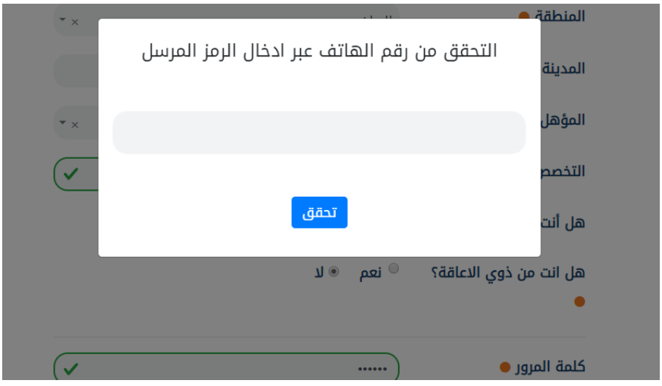
Fig. 30: Third Stage - Registration in SUBOL.

Online CV Builder/ Maker
SUBOL provides an Online CV Builder/ Maker, which can be accessed by clicking “Online CV Builder/ Maker” on the homepage (Fig. 4). CVs can be prepared in Arabic or English (Fig. 31), through five stages:
- Personal Information (Fig. 32).
- Academic Qualifications (Fig. 33).
- Certificates (Fig. 34).
- Work Experience (Fig. 35).
- Export as pdf or word (Fig. 36).
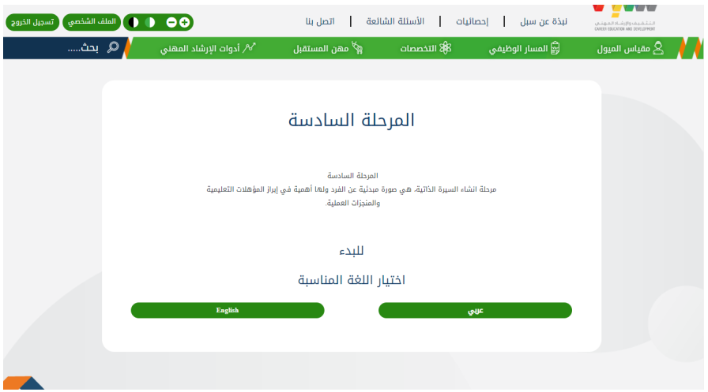
Fig. 31: CV Preparation - First Stage.

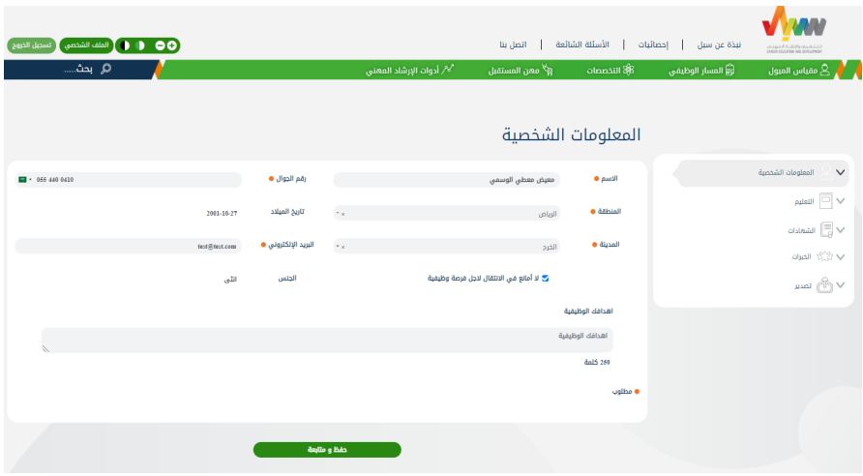
Fig. 32: CV Preparation - Second Stage.

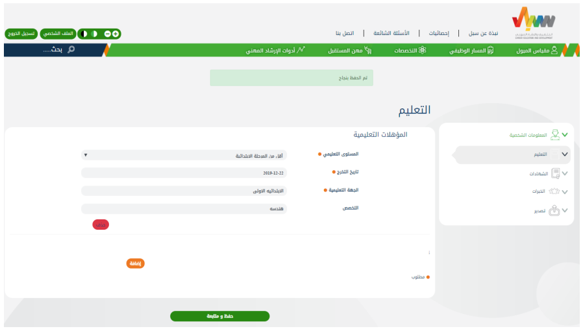
Fig. 33: CV Preparation - Third Stage.

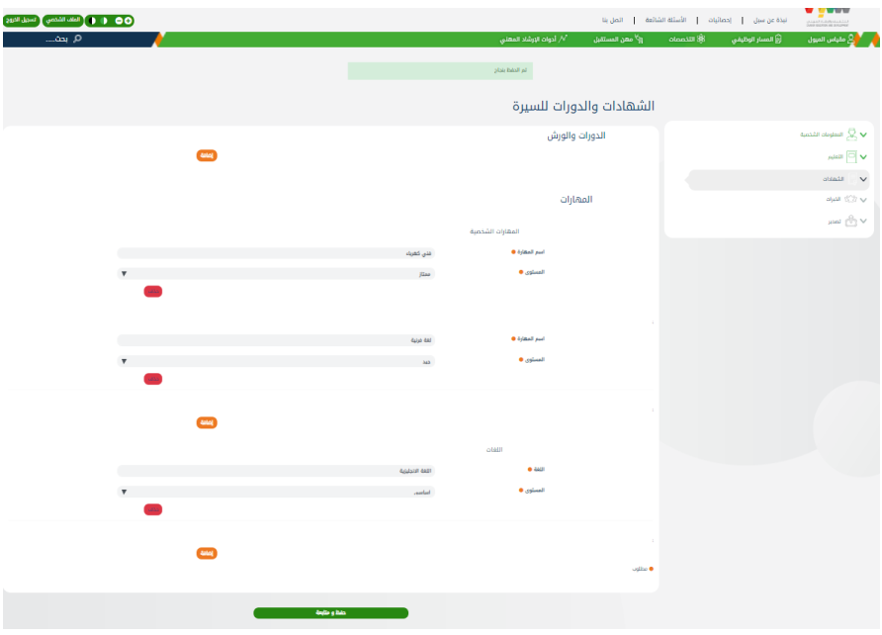
Fig. 34: CV Preparation - Fourth Stage.

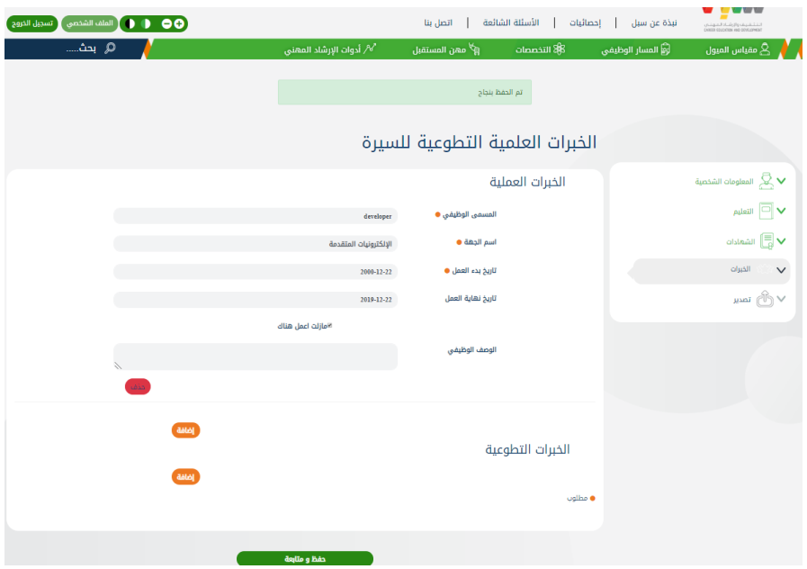
Fig. 35: CV Preparation - Fifth Stage.

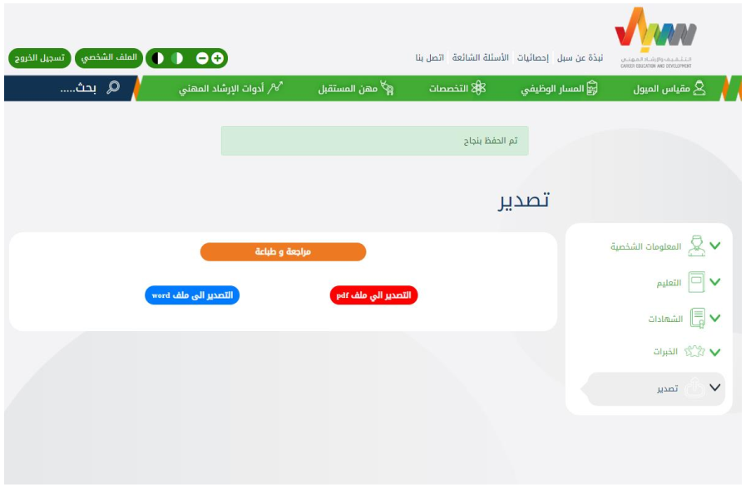
Fig. 36: CV Preparation - Sixth Stage.

Registered User Profile
Registered users can access their profile by selecting "Profile" in the top bar of the page. The profile displays all registered user details including:

- Preferred careers and majors.
- Registered DOROOB Courses.
- Registered Workshops (at HADAF headquarter).
- Career Orientation Test Results.
- CV (Arabic and English).
- Open and Closed Tickets.
- Career Development Services (career development tickets, appointments for booking a session, or communication with a career mentor).
- Personal information of the registered user.

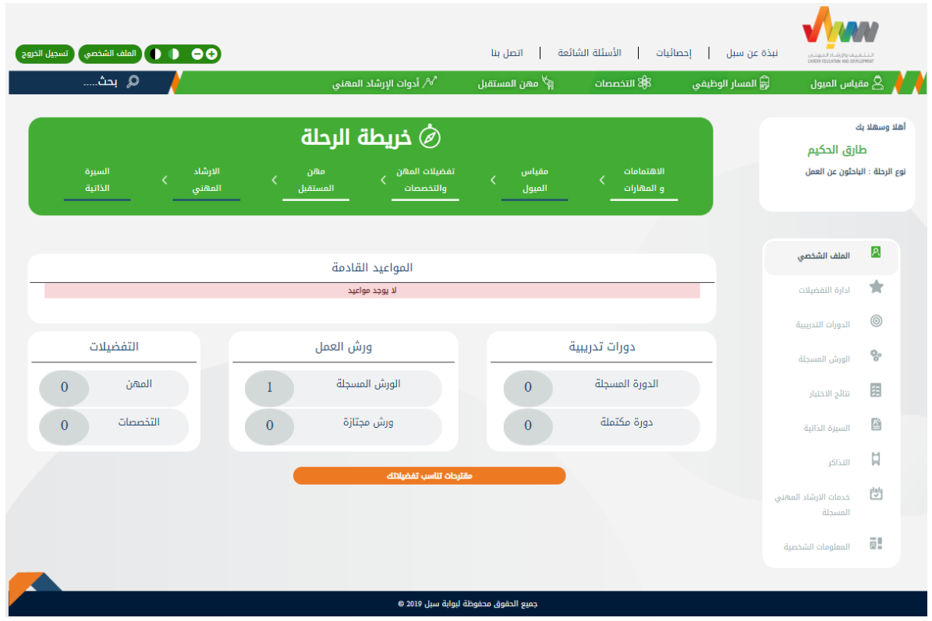

Fig. 37: User Profile.

