**Human Resources Development Fund**

**Program for Supporting Hospitality for Children (****Qurrah)**

Guide for Parents (Mothers)

**2023**

**Table Contents:**

* About Qurrah Program
* Qurrah Program Services for Parents
* Enrollment Conditions & Mothers' Registration Mechanism in Qurrah Program
* Mothers’ Registration Steps for Receiving “Qurrah” Support

**About Qurrah:**

* It is a national initiative of the Human Resources Development Fund. This initiative aims to support and empower Saudi working women to join the labor market and invest in it and reassure them of the childcare provided to her children by supporting her in bearing part of the costs of hosting her children by choosing one of the licensed centers close to her.

**Objectives:**

* Supporting and increasing the percentage of Saudi women working in the private sector, and contributing to their job stability,
* Improving and developing the environment and services of childcare centers in the Kingdom,
* Overcoming many barriers in the work environment for Saudi women in the Kingdom and balancing their responsibilities,
* Ensuring transparency and access to data and information related to childcare centers through Qurrah Portal, &
* Empowering different types of nurseries to raise the efficiency of this sector.

Qurrah Program Services for Parents in 2023



|  |  |
| --- | --- |
|  | Selection service of center according to the appropriate location of each mother |
| Diversity of provided services according to the age of the child |  |
|  | Electronic payment service for childcare centers by the beneficiary |
| A comprehensive platform for a number of licenses and non-licensed centers |  |

Enrollment Conditions & Mothers' Registration Mechanism In Qurrah Program



Support Conditions

* Saudi nationality,
* Monthly wage: (basic wage plus housing allowance) 8000 riyals or less,
* Registered in the social insurance,
* Age of the beneficiary's children: up to (6) years
* There is no maximum number of children.

Registration Method

* Register via the Portal "Hadaf",
* Log in Nafath, and then you will be transferred automatically to Jadarat,
* Log in Jadarat and activate the account, and then go to Hadaf programs and services,
* Go to Hadaf's website, select our programs, select "Qurrah" Program, and then register,
* Apply through "Qurrah" Program page of the Hadaf website,
* "Hadaf" will verify the eligibility of the candidate and fulfillment of the conditions for benefiting from the program,
* After receiving the beneficiary's eligibility notification via e-mail within 24 hours, go to Qurrah Portal,
* Register in Qurrah Portal and make sure to complete the required data,
* Add children, and then click on add child to support,
* Make sure to attach the required documents (a copy of child birth certificate), and determine the children to be included in the support and click on (add to support),
* Qurrah’s team will verify the eligibility of the child and make sure of the fulfillment of the conditions within 24 hours, and then you will be notified of acceptance or rejection via email,
* After you reserve the service and the Center accepts your request, your reservation will be confirmed after paying the deducted amount through the Portal (within a period not exceeding 24 hours from the time the center accepts the reservation) and you will be notified via e-mail and a text message that your supported reservation is confirmed,
* Reservation shall be made on a monthly basis, and you can start the service on any day of the month, provided that the reservation shall be made at a licensed center.

Mothers’ registration steps of for receiving “Qurrah” Support

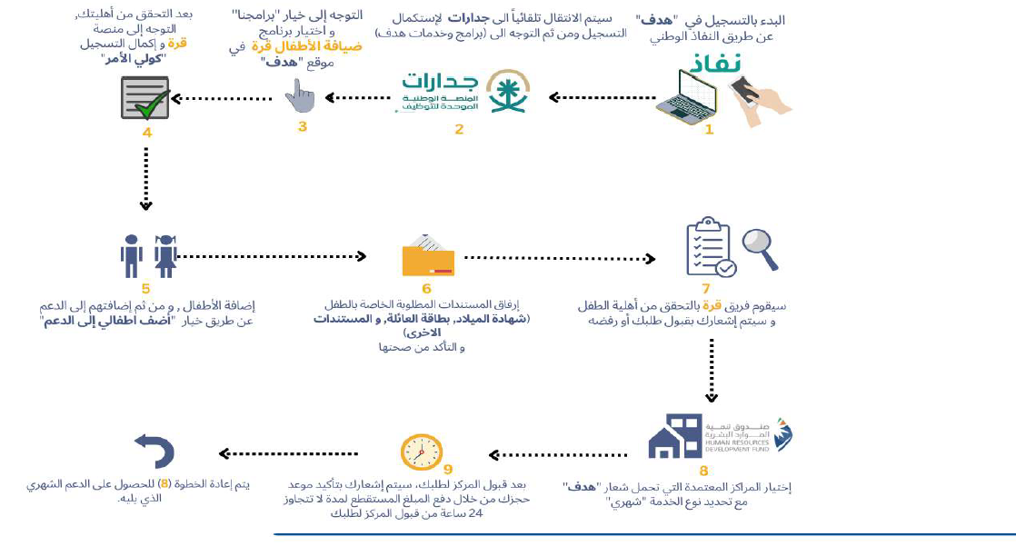

Steps of Mothers’ registration to receive “Qurrah” support in detail

|  |  |
| --- | --- |
|  | To receive support, kindly click on the link: Hadaf's Website |

Stage of registration in Taqat Portal for the receipt support

|  |  |
| --- | --- |
|  | * After clicking on Hadaf Website Link, a full page about Qurrah Program will appear * Kindly click on “log in” to complete the registration |
|  |

|  |  |
| --- | --- |
|  | * Log in Hadaf website * Have access through Nafath |

|  |  |
| --- | --- |
|  | * Log in Jadarat Website |

|  |  |
| --- | --- |
|  | * Press Next * Go to activation steps |

|  |  |
| --- | --- |
|  | * After activation, go to the Homepage and then click on “Hadaf Programs and Services” * Then, go to “Hadaf” website |

|  |  |
| --- | --- |
|  | * Go to “Our Programs” <Qurrah<Registration |

|  |  |
| --- | --- |
|  | Show Program Details |

|  |  |
| --- | --- |
|  | Acceptance of terms and conditions |

|  |  |
| --- | --- |
|  | Applicant is successfully registered in Hadaf website |

**Stage of Registration in Qurrah Platform**

|  |  |
| --- | --- |
|  | Go back to Qurrah platform after registration in Hadaf Website to complete registration and verify the beneficiary’s data |

|  |  |
| --- | --- |
|  | The emergence of a message means that your account is not activated. To activate your account, kindly press Activation Button |

|  |  |
| --- | --- |
|  | After the receipt of the activation code through the selected means (SMS or email), insert this code in the designated Cell |

**Child Addition Stage**

|  |  |
| --- | --- |
|  | Go to “My Children” Page to add children (Add children to support) |

|  |  |
| --- | --- |
|  | **Complete the basic information and verify the information** |

|  |  |
| --- | --- |
|  | **Complete the address-related information** |

|  |  |
| --- | --- |
|  | **Complete the health information, if any** |

|  |  |
| --- | --- |
|  | **After attaching the required documents and approval of data genuineness and the Program’s terms and conditions, kindly press “Send” icon.** |

|  |  |
| --- | --- |
|  | * After adding the child, kinky press “Add child to support” |

|  |  |
| --- | --- |
|  | * After adding the child to the support, your request will be sent to Qurrah team to verify the child’s birth certificate or family card, and a reply will be sent within 24 hours during working hours. |

**Points to be taken into consideration while booking a service for your child**

|  |  |
| --- | --- |
|  | * After selecting the Center suitable for you marked by Hadaf logo, * The Center’s service will appear, kindly select the service suitable for your child age * After the completion of booking, “Booking Confirmation” message will appear (kindly make sure that the booking is supported) so that you can benefit from the support, and then accept the Program’s terms and conditions. |

|  |  |
| --- | --- |
|  | * After the confirmation of booking, your request will be sent to the selected Center. Your request will be accepted or rejected by the Center within 72 hours. * Note: In case of non-receipt of acceptance or rejection message from the Center within 72 hours, the request will be canceled automatically. |

Method of Paying Booking Sum

|  |  |
| --- | --- |
|  | * After the Center accepts your request, kindly select the icon of bookings. For the confirmation of your request, payment will be made within 24 hours from the Center’s acceptance. You will receive a message of booking confirmation via email or text message. |

**Thank You**